**Programming Exercise 2-12**

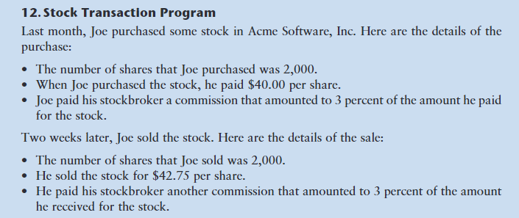

Write a python program called **stocks** that will do the following:

* Allows user to input all values for the stock transactions
* Performs the required calculations on the input variables
* Prints the resultant calculations
* Follows all input/output specifications as shown below
* Produces results that match those shown below

Do hand calculations so you know what your output results should be.

Use the flowchart below to help sequence your code. Your code will use inputs instead of constants.

Commit **stocks** to your github repository CS175L

Upload the github link to the dropbox.

Inputs and outputs from your program should look like this:

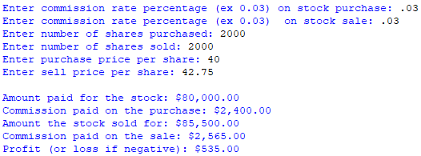

Flowchart

Constant Real COMMISSION_RATE = 0.03

Constant Integer NUM_SHARES = 2000

Constant Real PURCHASE_PRICE = 40.0

Constant Real SELLING_PRICE = 42.75

Declare Real amountPaidForStock

Declare Real purchaseCommission

Declare Real totalPaid

Declare Real stockSoldFor

Declare Real sellingCommission

Declare Real totalReceived

Declare Real profitOrLoss

Set amountPaidForStock = NUM_SHARES * PURCHASE_PRICE

Set purchaseCommission = COMMISSION_RATE * amountPaidForStock

A

Set totalPaid = amountPaidForStock + purchaseCommission

Set stockSoldFor = NUM_SHARES * SELLING_PRICE

Set sellingCommission = COMMISSION_RATE * stockSoldFor

Set profitOrLoss = totalReceived - totalPaid

Set totalReceived = stockSoldFor - sellingCommission

B

Display “Amount paid for stock: $”, amountPaidForStock

End

Display “Profit (or loss if negative): $, profitOrLoss

Display “Commission paid on the sale: $”, sellingCommission

Display “Amount the stock sold for: $”, stockSoldFor

Start

A

B

Display “Commission paid on the purchase: $”, purchaseCommission